**Response for Assignment 1.1**

/* Below screenshots show the installation of

1. Python 3.6
2. Anaconda
3. Spyder (will use this primary editor)

*/

**Anaconda**

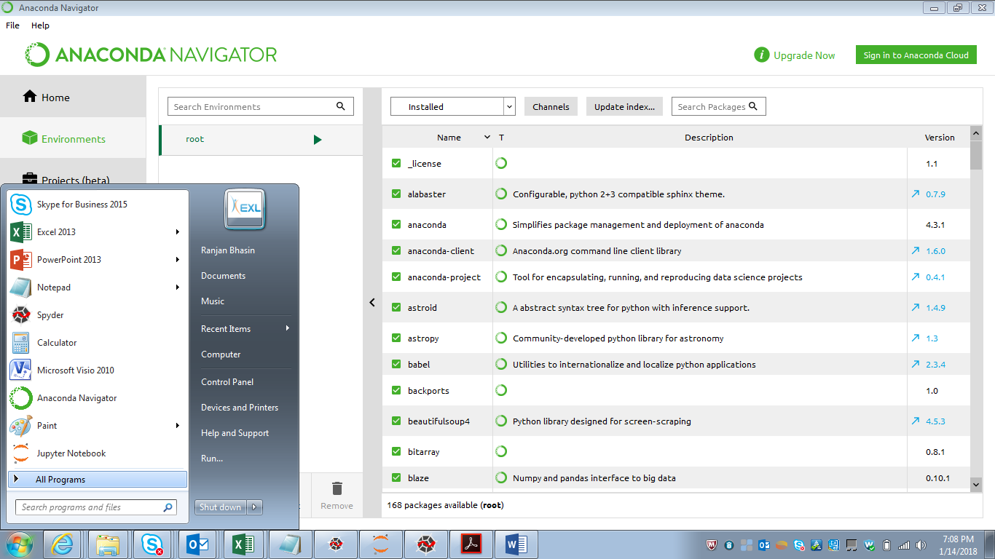

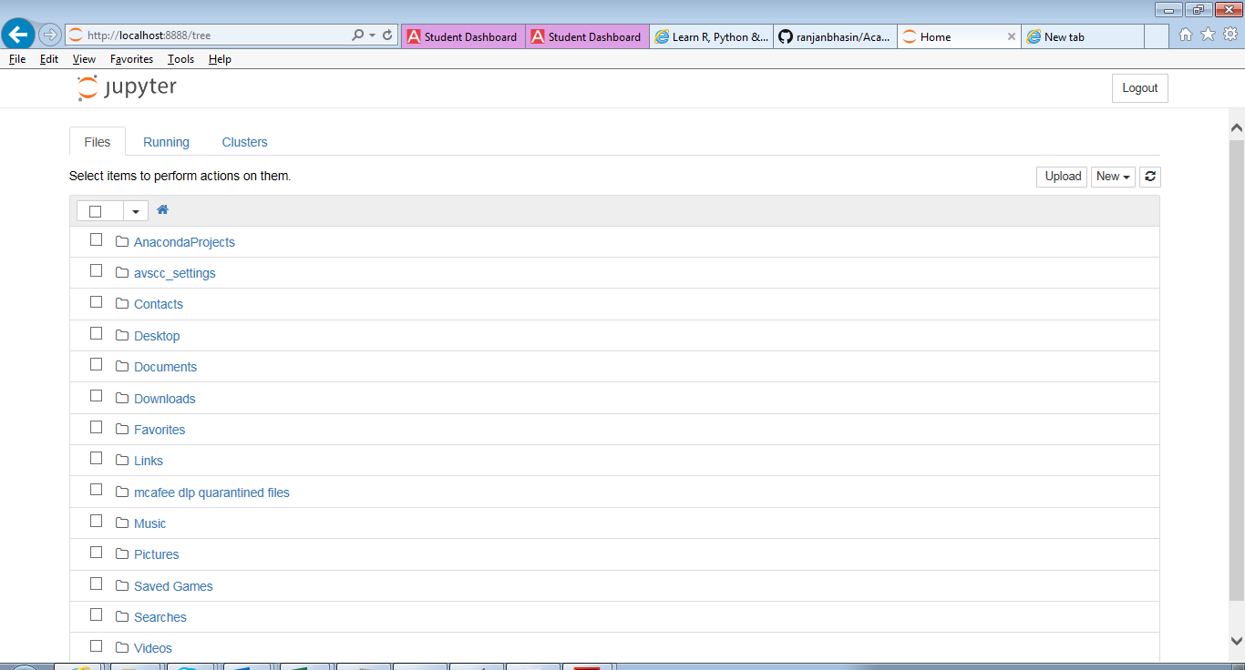

**Python Installation**

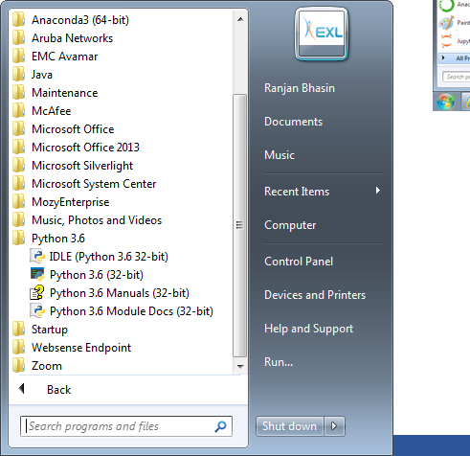

**Spyder editor**

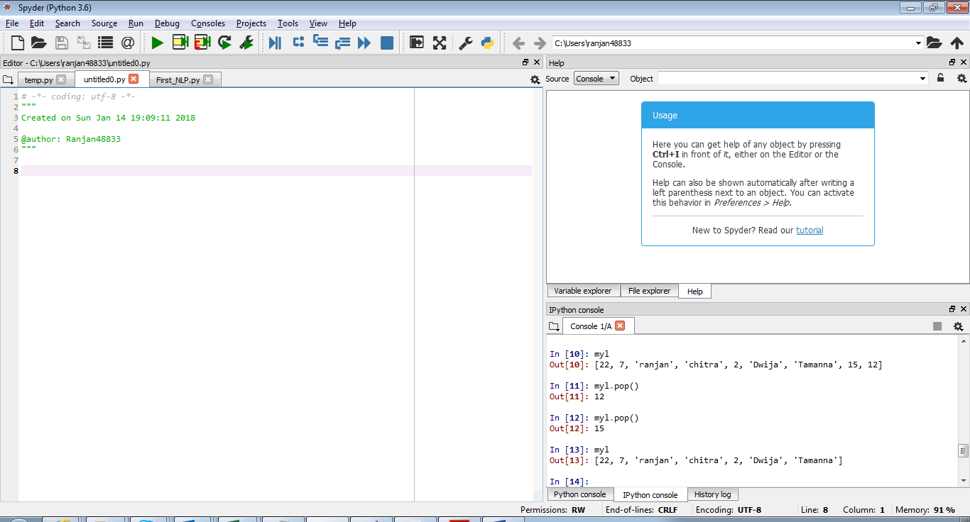

**Below screenshot shows program and output** – left side shows program and right bottom shows output of program.

